
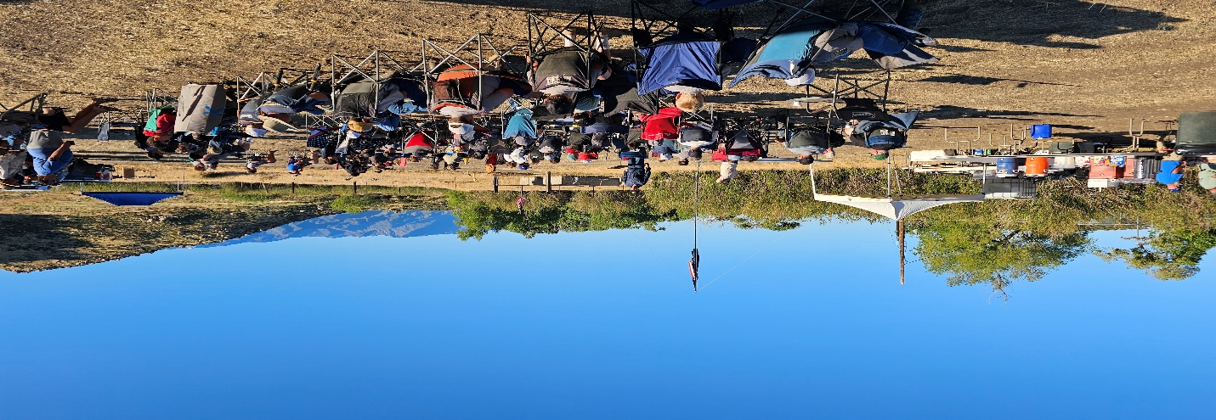
August 10, 2026

CADETS

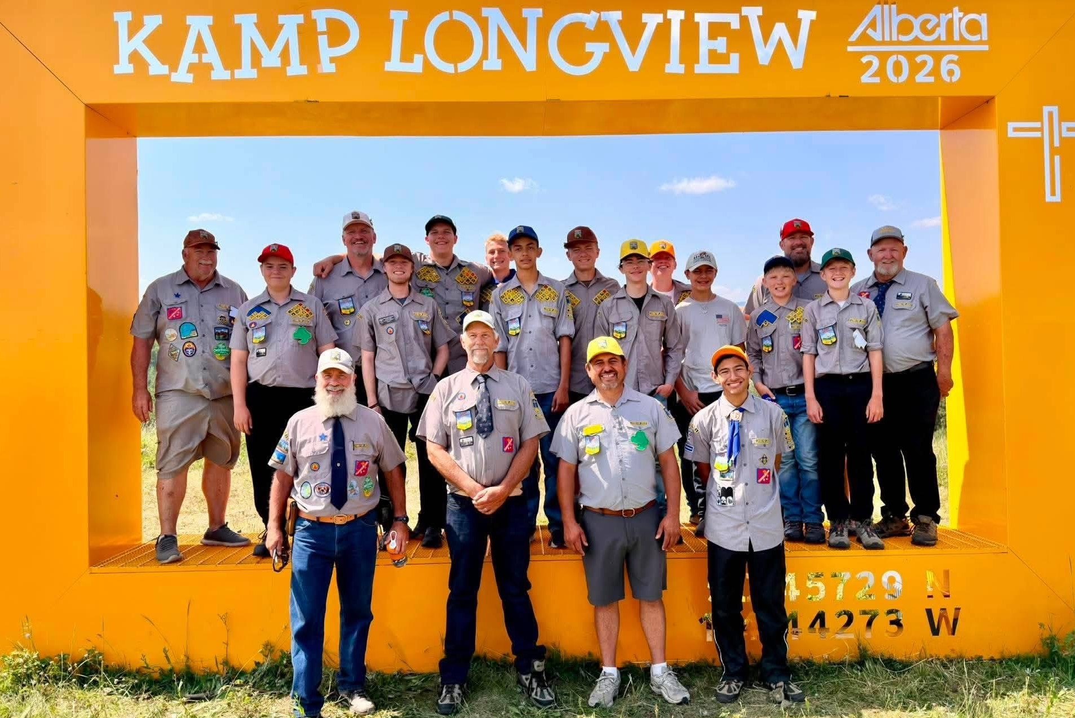

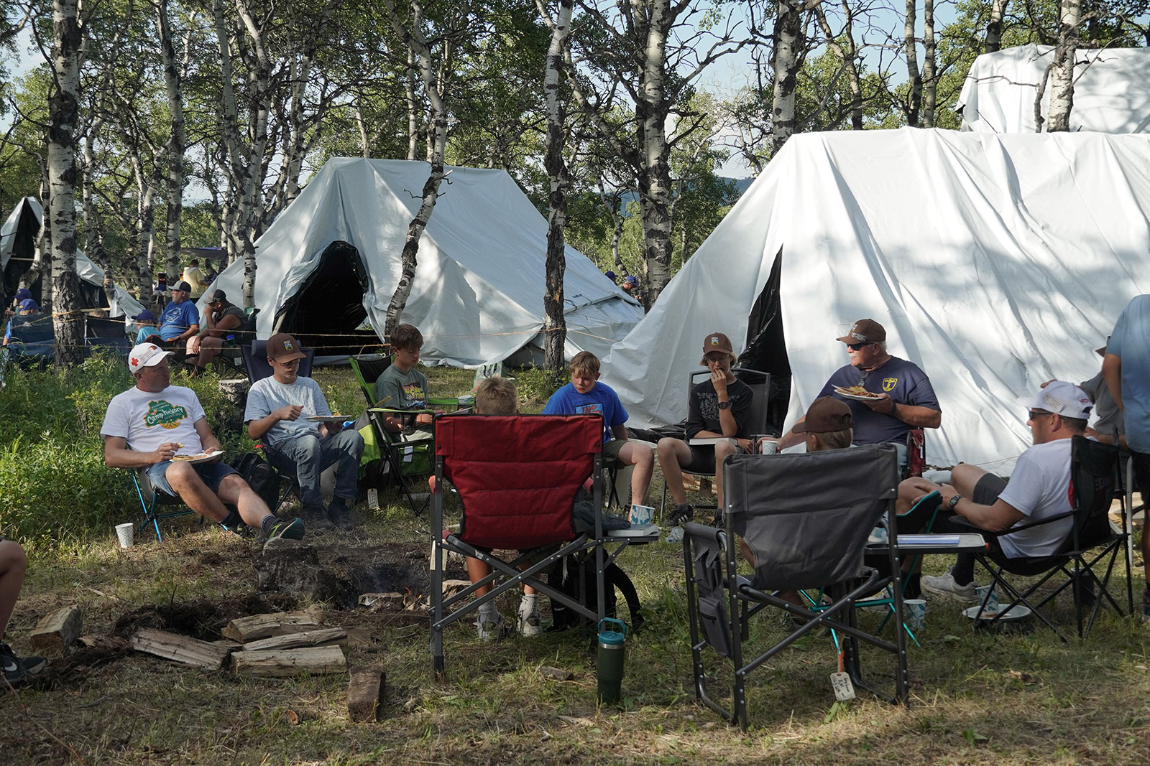
Cross Point Church

6950 Edison Ave.
Chino, Ca. 91710

For Information, Please Contact
Randy Mouw at (909) 725-2567 or randrmouw@gmail.com

Tony De Vries (909) 917-4577 Tonydevriespestcontrol77@gmail.com

Our theme this year is based on Psalm 125:2 “As the mountains surrounds Jerusalem, so the Lord surrounds His People, both no and forevermore

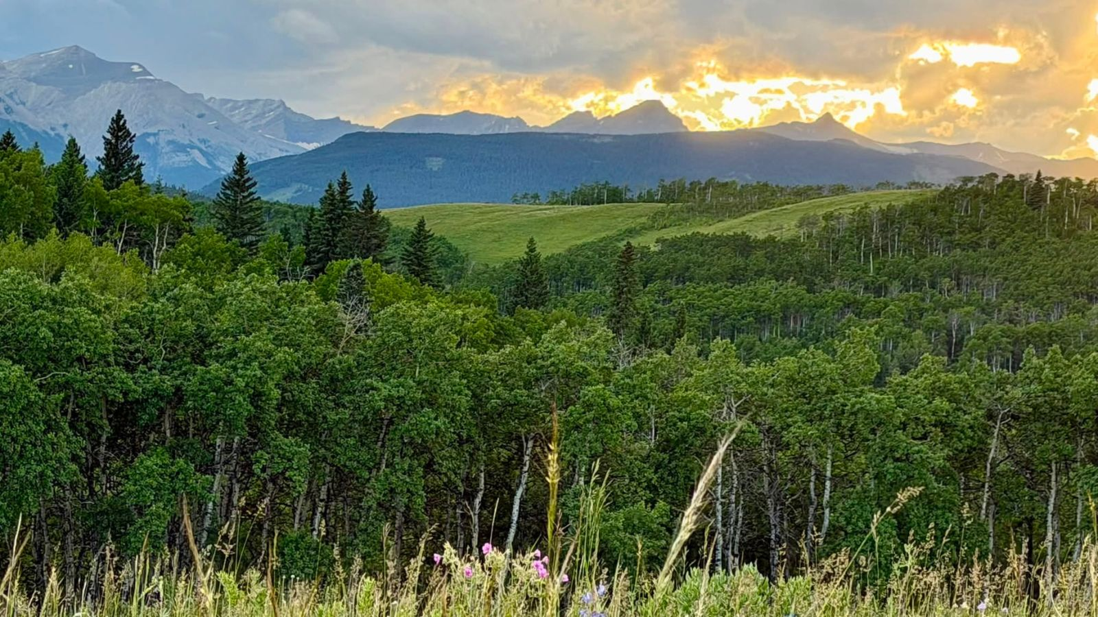


https://camporee.calvinistcadets.org/wp-content/uploads/DSC06966-copy.jpg

Delete text and place photo here.

Where: CrossPoint Church Cadet Room

(Maintenance Building)

When: Every Wednesday of the month

Time: 6:30 pm to 8:00pm

The Goal of Cadeting
The Goal of Cadeting Luke 2:52 states that "Jesus grew in wisdom and stature, and in favor with God and men." The goal of the Calvinist Cadet Corps, based upon that verse, is to help boys to grow spiritually in all areas of life (devotional, mental, physical, and social) by providing Christian men with a uniquely designed structure, program, and materials so that they can mentor boys effectively.

Helping Boys to grow more Christlike in all areas of life.

2026 International
Camporee

LIVING FOR JESUS

Mountains Of Blessings

August 10, 2026

Recruit • Pathfinder • Builder Ministry
Here is the heart of the Cadet organization. Boys and their counselors working side by side on Bible lessons, Christian service projects, outdoor activities (camping, cycling, hiking, canoeing, and much more), and working on merit badge projects -- selecting from a wide range of interests and skills.
More than 100 merit badges are offered in this program. The counselor challenges, guides, encourages, listens, and counsels the boys as an expression of God's love

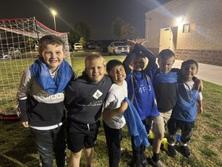
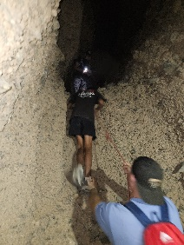
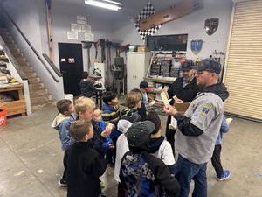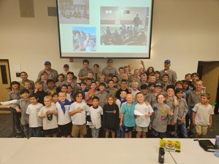
- First Meeting August 19, 2026!!
- Parent Meetting August 26 at 7:20
- Family event September 12, 2026
- Father Son Friend Campout October 9-11 in Gold Country!
- November 18 – Opeation Christmas Child
- Thanksgiving Break Nov.25
- December 5, 2026 Field Day at Ontario Christian Home Field advantage!
- December 16-January 5 Christmas Break

Mountains Of Blessings
HERE ARE SOME UP COMING EVENT Dates to look for
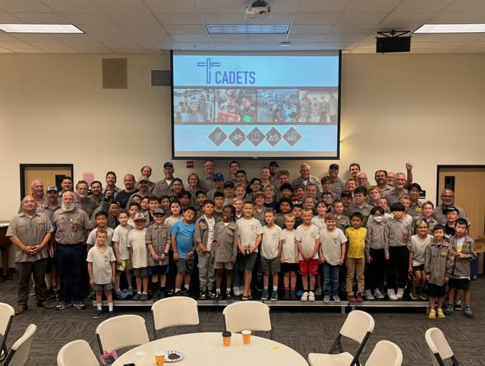

Delete text and place photo here.

Special Points of Interest
and/or call-outs

An opportunity to call out an interesting point you may like to share with your audience

“Stay away from using jargon, acronyms,
or complicated terms. Quotes are enjoyable.”

Cross Point Church - www.crosspointchino.org

Write captions for the selected photos.

Write captions for the selected photos.

Continue newsletter text here. Continue newsletter text here. Continue newsletter text here. Continue newsletter text here. Continue newsletter text here. Continue newsletter text here.

Continue newsletter text here. Continue newsletter text here. Continue newsletter text here.
Continue newsletter text here. Continue newsletter text here. Continue newsletter text here. Continue newsletter text here.

